UNIT 4

HUMAN BIOLOGY

BIOTECHNOLOGY

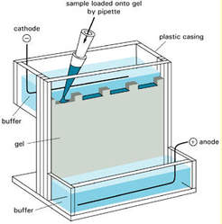

(www.iclane.net)

NAME: ________________________

FORM: ________________________

Biotechnology

What is biotechnology?
Biotechnology is the practice of using living things (plants, animals and micro-organisms such as bacteria), as well as knowledge of biological cellular processes to make products that are of use to humans. Eg. Using yeast to make bread and alcohol and bacteria to make cheese and yoghurt.
Biotechnology is used in gene testing, gene manipulation, gene replacement, cell replacement therapies and tissue engineering. It is also used in treatment and prevention of diseases.

Draw a labelled diagram of a section of a DNA molecule.

Draw a diagram of an adenine nucleotide:

GLOSSARY
Genome

Human genome project

Gene pool

Restriction enzyme
Ligase

Ligation

DNA polymerase
Sticky end
Blunt end
Vector
Plasmid
Polymerase chain reaction
Recombinant gene
Transformation
Transgenic organism
Primer
Oligonucleotides
Dideoxynucleotide
Electrophoresis
Genetic profile
Gene probe
Microarray
Gene splicing
Denature

Anneal

Hybridised

GENETIC ENGINEERING TECHNIQUES

Three types of DNA enzymes (nucleases) are used

- Nucleic acid polymerase: involved in synthesis of nucleic acids

- DNA ligase: an enzyme found in the bacterium Escherichia coli (E. coli) can be used to join DNA strands or the ‘sticky’ ends of DNA strands together. DNA ligase acts by forming a phosphodiester bond between 2 fragments of DNA. It joins the 3’ OH end of one nucleotide with the 5’ phosphate end of another nucleotide. This process is called ligation.
- DNA ligase can recombine DNA from the same species and different organisms, including different species.
- Restriction enzyme : Enzymes that act as molecular scissors that always cut DNA at specific points it recognises specific short nucleotide sequences, usually 4-6 base pairs long and arranged as a palindrome, this is the recognition site.
For example, the enzyme EcoRI, which is taken from the human gut bacteria E. coli, recognises the genetic sequence GAATTC. It cuts the DNA between the guanine (G) and the adenine (A).
[refer to recombinant DNA discovery of enzymes in bacteria (the restriction enzymes) restricting the duplication of viruses that invade bacteria (bacteriophages) by cutting the viral DNA and therefore restricting the duplication of the virus.]

CUTTING OF DNA

Viruses that infect bacterial cells are called bacteriophages or phages.
Certain enzymes in bacteria are able to restrict the duplication of infected viruses by cutting up the viral DNA and are known as restriction enzymes.

These enzymes always cut the DNA at a point where there are specific base sequences of bases. This is known as the recognition site

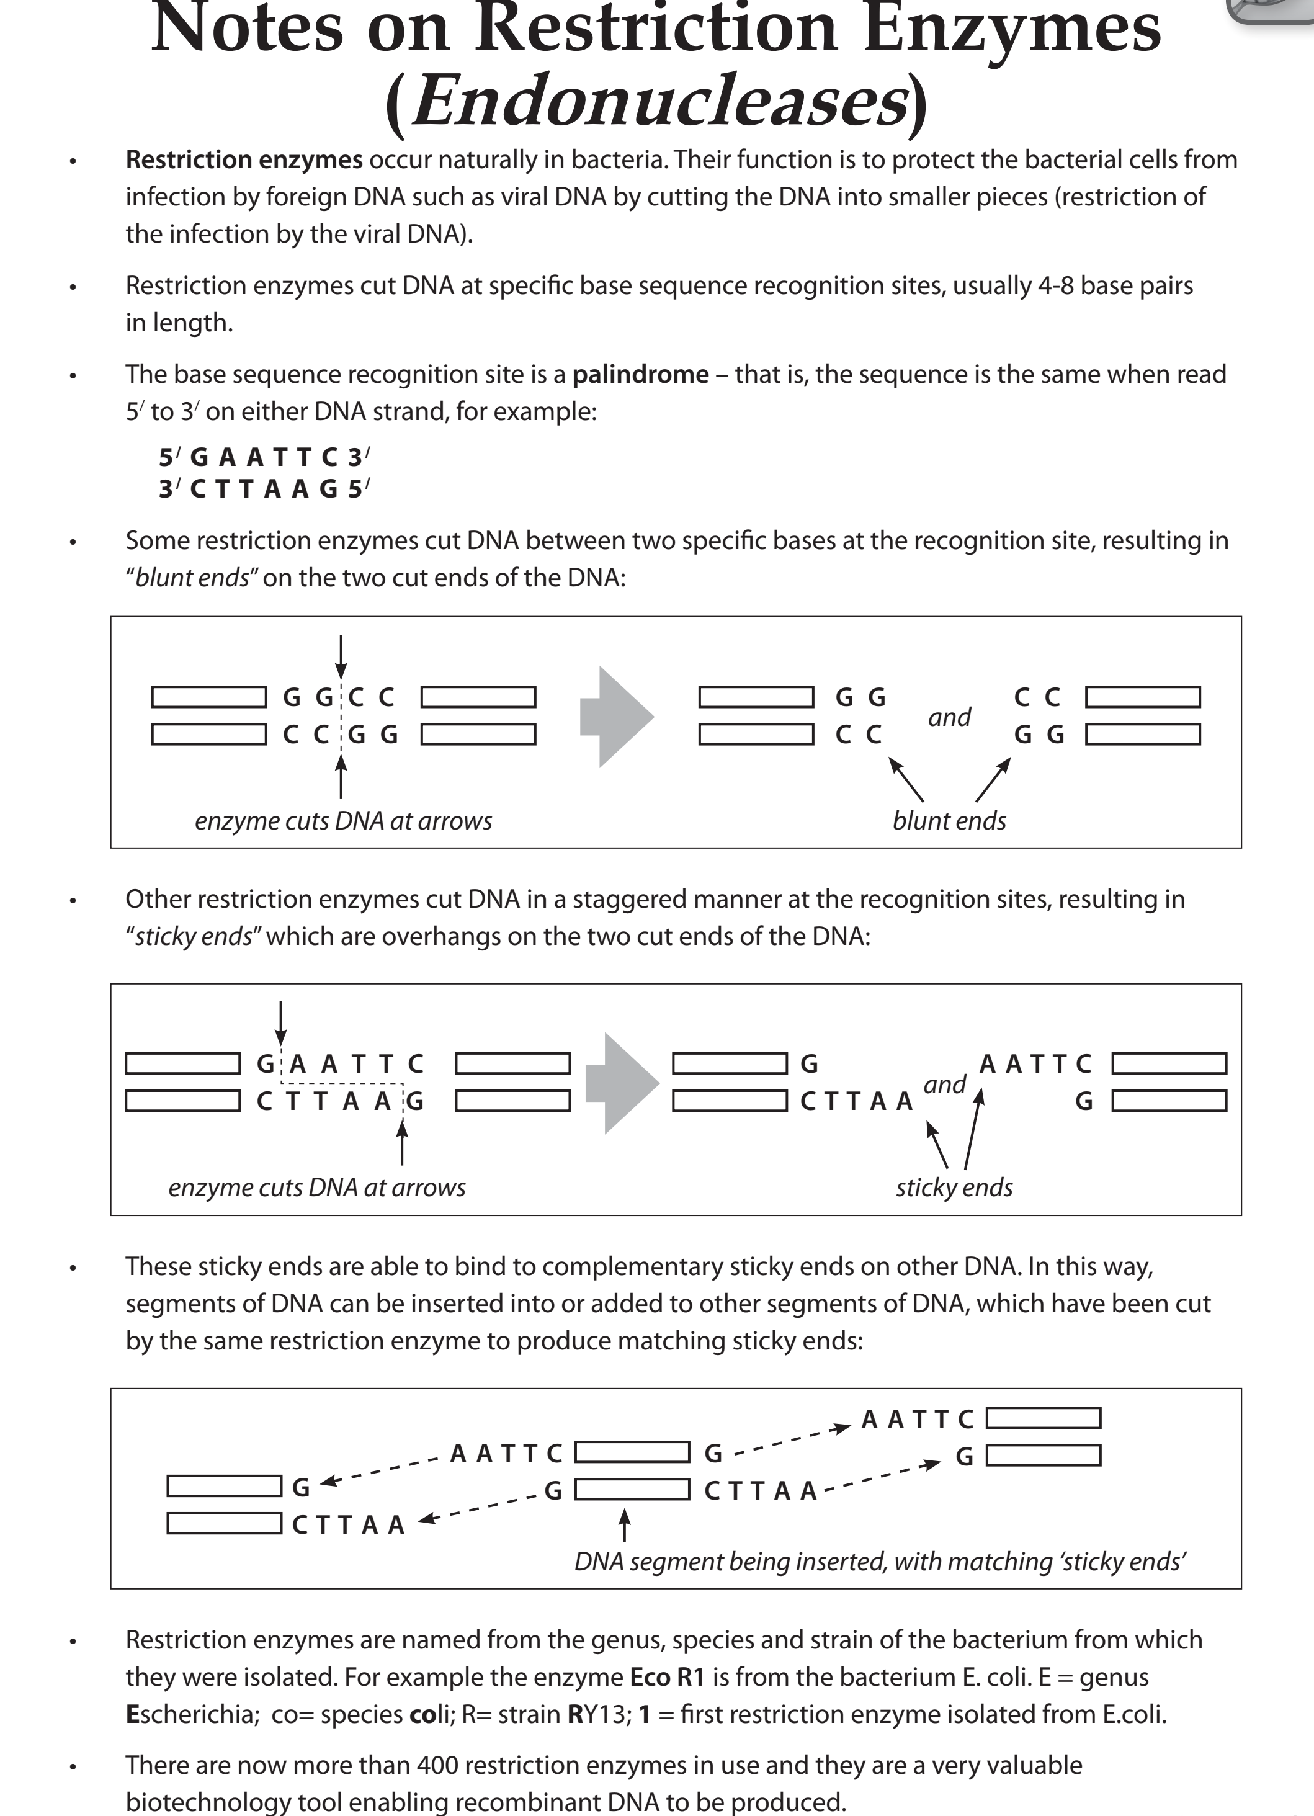

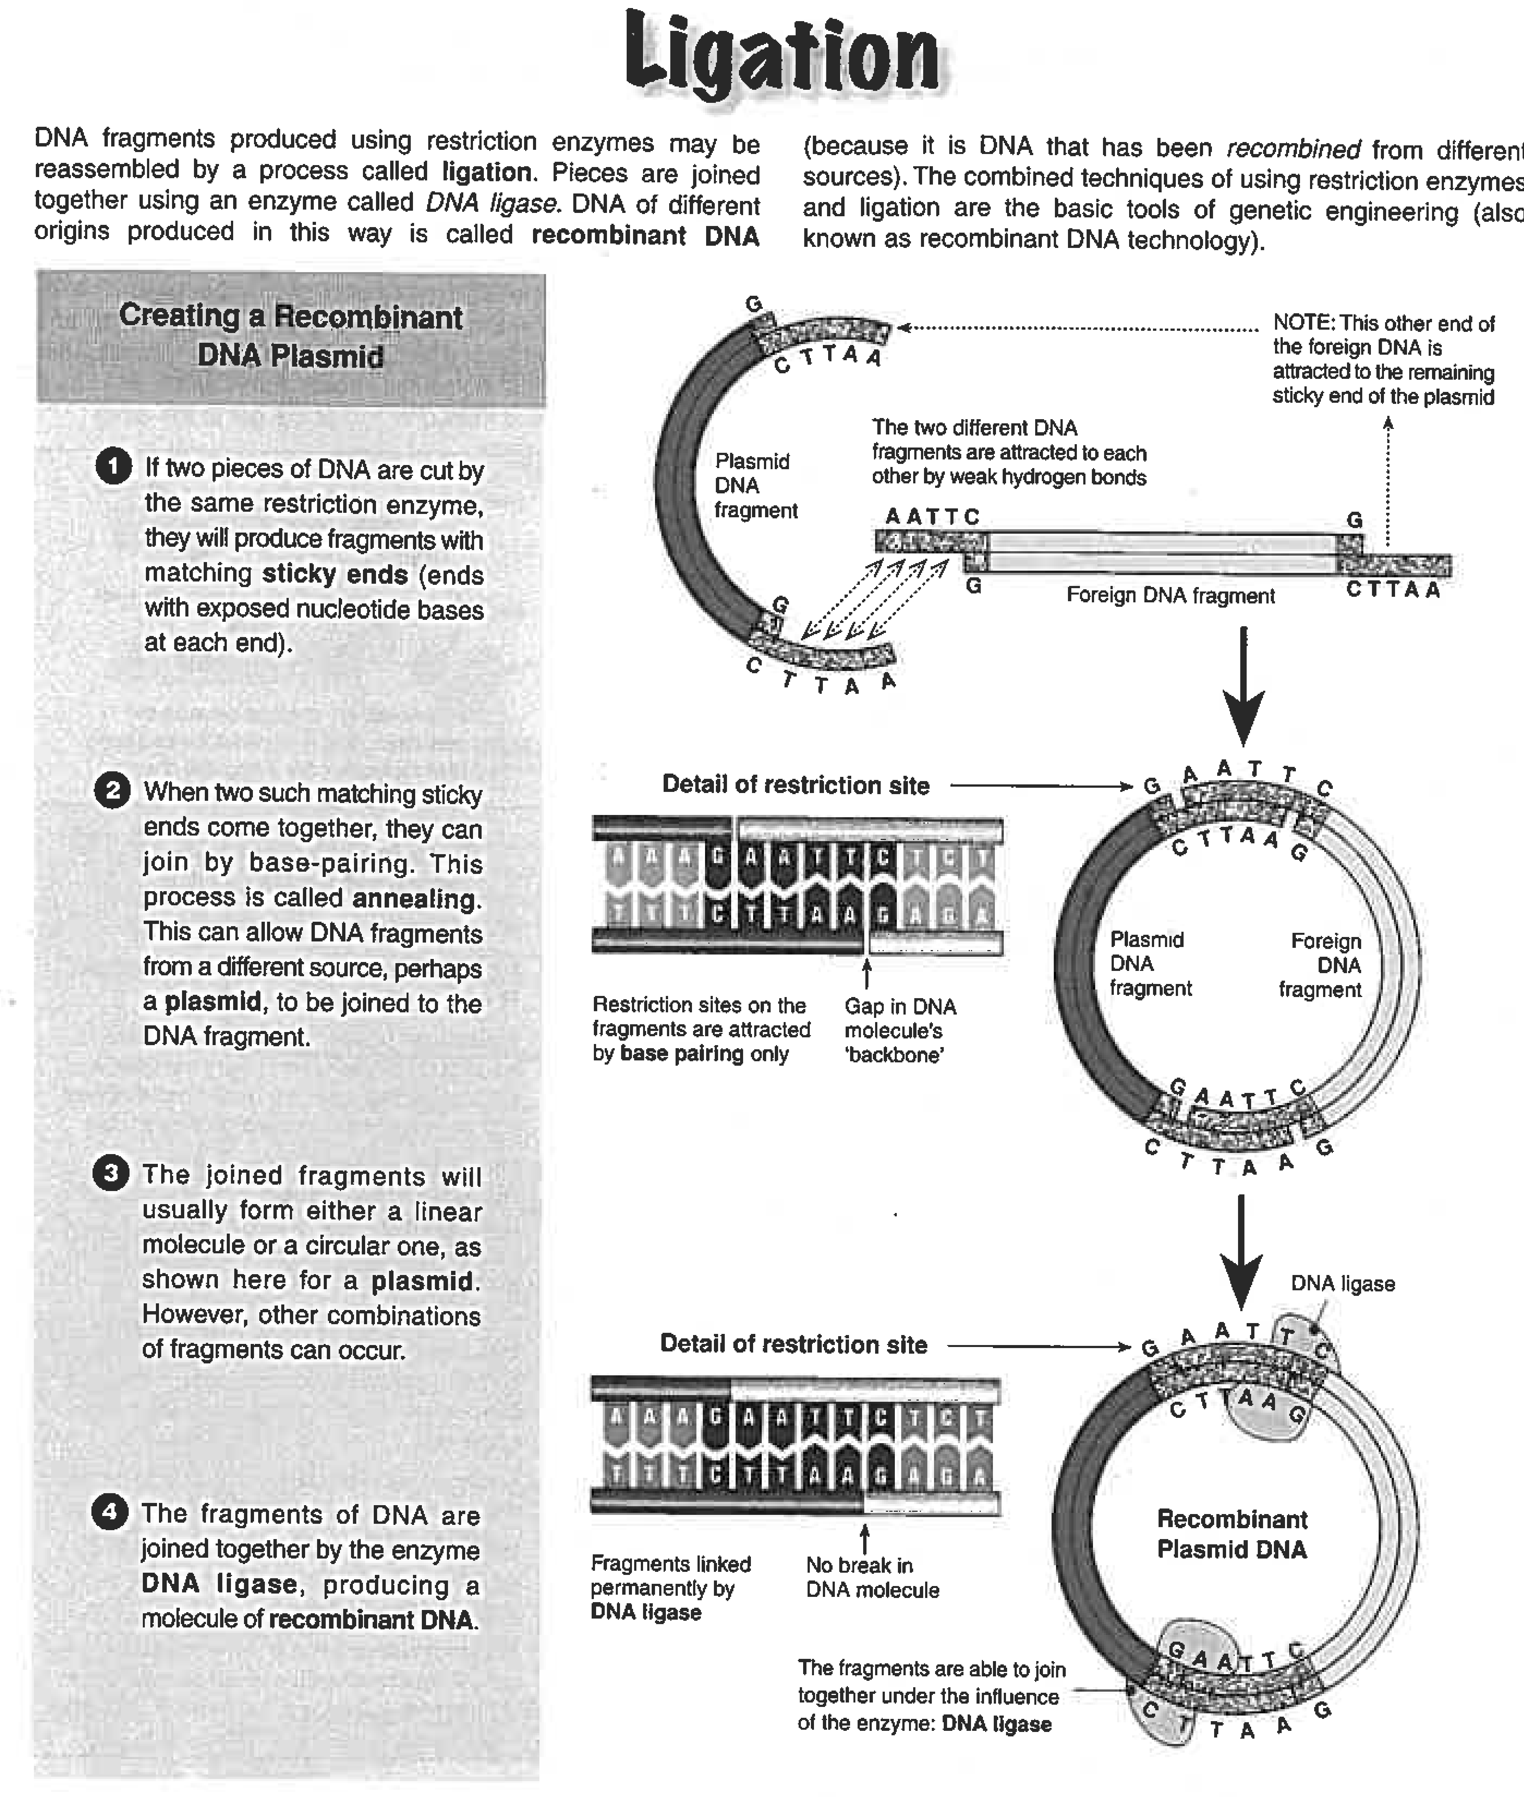

The cut piece of DNA can be pasted either into a new chromosome, virus or into a plasmid - one of the small circular DNA molecules found in bacteria. Plasmids are used when transferring a gene from one organism to another. The name given to the plasmid in this process is called a ‘Vector’.
The DNA of the plasmid is cut with the same restriction enzyme that was used to cut the gene out. This means the sticky ends will have the same DNA code as the ends of the piece being pasted in. The overhanging strands of DNA bind together, and another enzyme, called ligase, is used to seal the join.

POLYMERASE CHAIN REACTION: - PCR http://learn.genetics.utah.edu/content/labs/pcr
This is the process that amplifies a specific DNA sequence. This means to make many identical copies (sometimes called clones) of a specific sequence of DNA very quickly. The sequence of the DNA is duplicated many times in a common laboratory using the enzyme DNA Polymerase. Such compounding amplification of the original molecule has resulted in the process being called chain reaction.
To study genes, researchers need large amounts of DNA to work with. PCR copies the cell’s natural ability to replicate its DNA and can generate billions of copies within a couple of hours.
USES:
1. PCR is used to detect hereditary disease quickly. PCR is used to amplify gene of interest so that it can be sequenced to detect if gene has a mutation such as sickle-cell anaemia, PKU – phenylketonuria or cystic fibrosis.
2. Amplification of viral DNA and early detection of viral diseases immediately after infection can lead to early intervention and management of this viral disease.
3. Forensics: amplification of DNA from a single drop of semen or cell or strand of hair at a crime scene. Amplified copies are used in DNA profiling for identifying individuals from their unique DNA/ also comparing an individual’s DNA to a library of DNA from known individuals.
4. Used to determine relationships between human ancestors. Small amounts of DNA extracted from fossils can be amplified and DNA of ancestors can be sequenced. Can be used to determine a fossil’s position in a phylogenetic tree. Phylogenetic analysis of fossils eg Neanderthal

COMPONENTS REQUIRED FOR PCR.
- Thermo-cycler
- Epindorf Tube
- DNA sample to be copied
- Enzyme: Heat resistant DNA Polymerase enzyme called Thermus aquaticus (Taq)
- Buffer to create correct medium for enzyme to function
- Supply of A, T, C, G nucleotides
- Two primers (reverse and forward primer) complementary to two ends of DNA to be copied.
A primer is a short piece of single stranded DNA, complementary to the targeted sequence of DNA and it initiates/starts replication by DNA polymerase.
Primer binds/anneals to each DNA strand by complementary base paring to the 3’ end of each complementary strand.
Oligo primers: Oligonucleotides are short nucleic acid polymers used in research, genetic testing and forensics. Oligonucleotides are usually made up of 13 to 25 nucleotides and are designed to hybridize specifically to DNA or RNA sequences.

There are THREE main steps:

- DENATURING: The DNA to be copied is heated to approximately 94-98 ºC, which causes the paired strands to separate by breaking the weak hydrogen bonds (DNA strands denature). The resulting single strands are now accessible to short lengths of DNA called primers.

- PRIMER ANNEALING/ HYBRIDISATION: Temperature reduced to 50-65 º C to allow base pairing and formation of H – bonds. The primers, short single strand of DNA, anneal (join) to complementary sequences along the DNA strand, in front of the gene that is to be copied. Forward and reverse primers attached at two opposite ends of the template strands to allow 5’ – 3’ extension.

- EXTENSION: The reaction mixture is then heated to about 72 º C.
Enzyme used in extension in PCR is a heat-stable endonuclease, called Taq polymerase which originally came from a bacterium that lives in hot springs. It can withstand the high temperature necessary for DNA strand separation and therefore, can be left in the reaction and still functions.
Taq polymerase binds to primer and synthesise a new DNA strand by adding nucleotides in a sequential manner, complementary to the DNA template strand. At the end of this phase there are two copies of the double-stranded DNA.
REPEAT: The above steps are repeated until enough DNA is obtained. By using PCR an original DNA template can be amplified over many sequences to generate millions of copies of the original DNA molecule. (After 30 cycles already billions of copies) The compounding amplification of the original material has resulted in a process referred to as a chain reaction.
This whole process is automated and happens in a couple of hours. The reaction occurs in a small tube (Eppendorf) placed inside a specialised machine called a thermocycler that can make the big temperature adjustments quickly.

State applications of PCR

Write down all the KEYWORDS that you will use in explanation of process of PCR

___________________________________________________________________________________________________________________________________________________________________________________________________________________________________________________________________________________________________________________________________________________________________________________________________________________________________________________________________________________________________

Write down all the steps involved in PCR

RECOMBINANT DNA (rDNA)TECHNOLOGY - Genetic Engineering
rDNA technology or genetic engineering involves the introduction of foreign DNA or DNA that has been modified into an organism.

USES:

1. This has huge potential for replacing faulty genes with healthy ones. Can be used in gene replacement therapy and could benefit patients suffering from cystic fibrosis, rheumatoid arthritis and certain cancers.

2. Making large quantities of pure protein for medical use including insulin, growth hormone, factor VIII and FSH (follicle stimulating hormone). The human gene is inserted into bacteria that become bio-factories

FOR YOUR INTEREST ONLY:

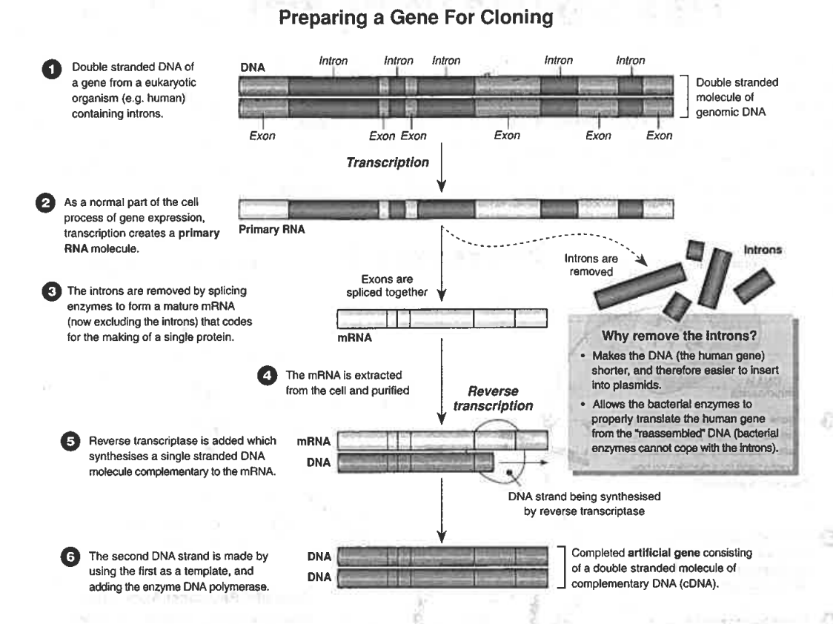

rDNA TECHNOLOGY

STEP 1. Isolate the gene of interest (alien to the vector) from donor genome using a restriction enzyme

STEP 2: Insert this gene into a vector such as a phage virus or bacterial plasmid using enzyme ligase.
Now referred to as recombinant DNA. A vector is a self-replicating DNA molecule e.g. plasmid, viral DNA or used to transmit a gene from one organism to another. Vectors need to be able to replicate inside their host
A plasmid is a circular double-stranded unit of cytoplasmic DNA found in bacteria that are capable of replicating within a cell independently of the chromosomal DNA.

STEP 3: TRANSFORMATION: The process of bacteria taking up the plasmid.
Plasmids genes often contains gene for resistance to antibiotics. Bacteria that has been transformed (taken up the plasmid) will grow on medium that is supplied with antibiotics. Bacteria that has not taken up the plasmid will not be able to grow on a medium with antibiotics.
STEP 4: Clone the gene / bacteria containing transgene reproduces so that numerous copies of DNA is available to insert into host cells. Or DNA is inserted into a virus acting as a vector. When virus enters an organism’s cell, it will reproduce inside host cell to produce more copies.

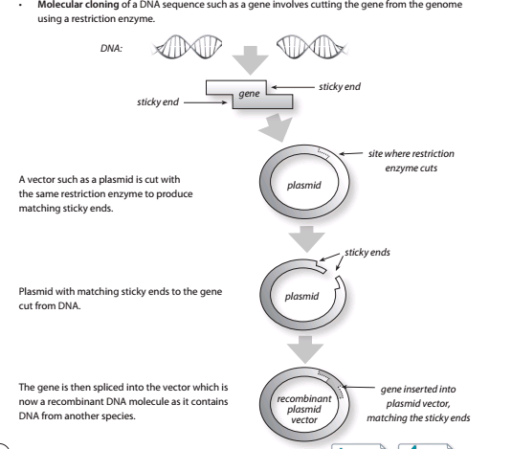
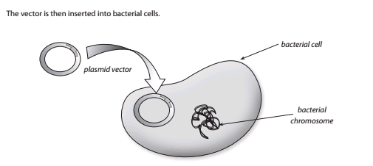

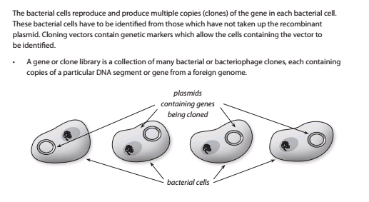
A bacterium which has a recombinant gene (a gene which has been inserted on a foreign organism’s DNA) spliced to its plasmid, will replicate its entire DNA, including the recombinant gene, each time it divides. An organism with a gene spiced into it from another organism, is called a transgenic organism. Therefore, if kept in optimal conditions, millions of copies of the gene can be made in a very short period of time (bacteria divide approximately once every 20 minutes).
The new recombinant DNA can change the function of the bacteria. The bacterium has a gene which it did not previously have. Therefore, it may synthesise a protein which a normal unmodified bacterium would not synthesise.
INSULIN PRODUCTION: Bacteria into which the gene for insulin production has been introduced are now used to manufacture insulin for treatment of diabetes.
DIAGRAM OF RECOMBINANT DNA TECHNOLOGY
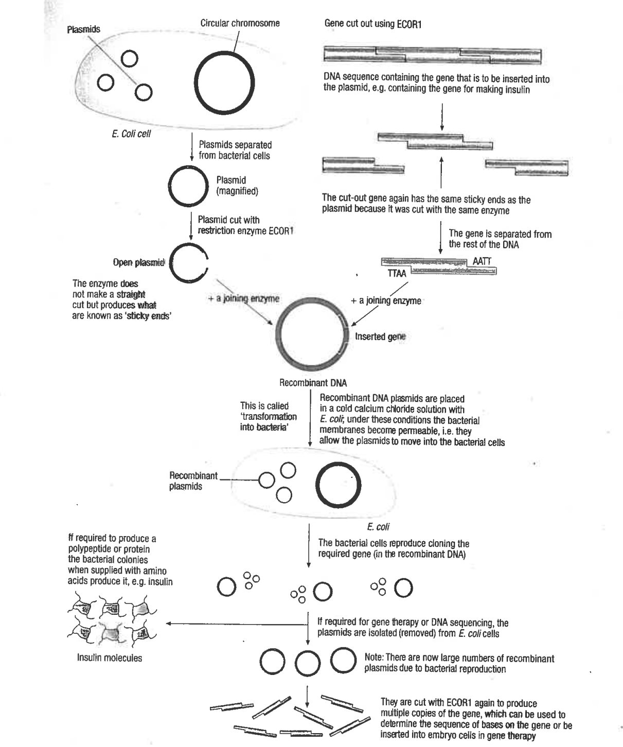
In insulin production the bacteria, make many copies of the transgene and translates the insulin code into insulin. Insulin is then extracted and purified to be used by humans.

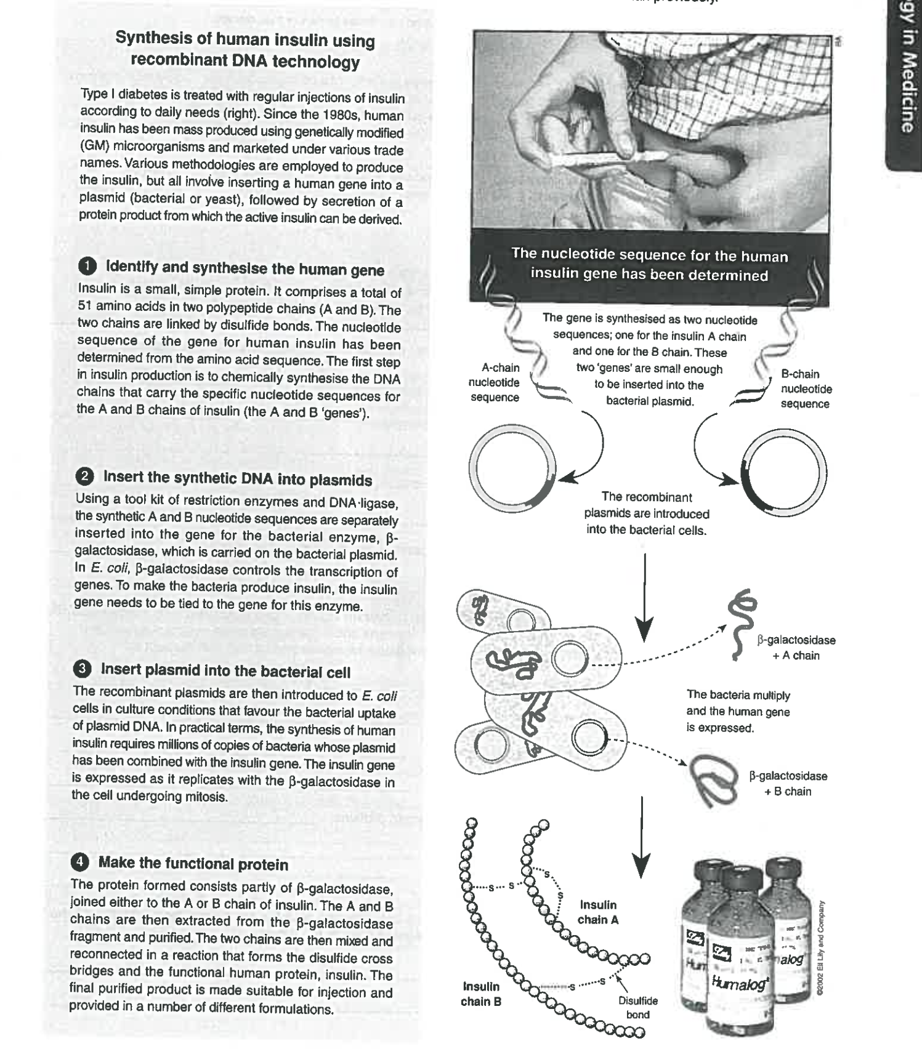

Give two applications of rDNA technology

Write down all the key words that you will use in explanation of r DNA technology

Write down all the steps involved in the production of insulin using rDNA technology

- Discuss how the vaccine for Hepatitis B could be produced using biotechnology. (12 marks)

- The gene/ segment of DNA for the antigen (in case of Hep B, the DNA code for protein capsule of virus) is isolated by cutting at the recognition site.
- Using a restriction enzyme, cuts the nucleotide bonds on either side of the gene in a blunt or sticky end, overhanging edges/ complementary strands this is called cleaving (not required).
- These overhangs are useful as the unpaired nucleotides will pair with the other overhangs made using the same restriction enzyme.
- PCR can be used here to make many copies (amplification) of target gene
- A plasmid (circular strand of DNA found within a bacterial cell (or in case of Hep virus vaccine prep – yeast cells) purified from a bacteria cell or yeast cells.
- Plasmid is cut with the same restriction enzyme.
- DNA ligase enzyme, joins the isolated gene and plasmid together, creating a diester bond between phosphate of one nucleotide and hydroxyl group of previous nucleotide.
- The donor DNA and the vector DNA will splice together. The resulting molecule is called Recombinant DNA
- Plasmid is now called a vector.
- The vector is placed in a solution with live yeast (bacterial) cells that have been specially treated to make their cells more permeable to DNA. Recombinant plasmids enter the virus or bacterial cell.
- If a yeast or bacteria cell takes up the transgenic plasmid (vector) the virus or bacteria have been transformed.
- To test if a bacteria has been transformed, bacteria will be exposed to antibiotics, bacteria without plasmid will die as antibiotic resistant gene is in plasmid.
Organisms are now called transgenic. (Gene from another organism in their plasmids)
- Cloning of transgenic organisms plasmids, making multiple of target gene.
- Provide bacteria or yeast with amino acids
- Yeast or bacteria will now produce the protein of the virus protein capsule.
- The protein will be purified and used as a vaccine against Hep B

Hormone production:

- Provide amino acids and then remove the vaccine and purify
- And produces large amounts of the gene or its product/ vaccine through transcription/translation

DNA PROFILING – DNA FINGERPRINT

This is a process that can be used to compare the base sequences of two or more individuals to determine how similar or how different they are. This is used to trace ancestry and in forensic science. They are also useful in identification of hereditary diseases such as cystic fibrosis. A recent discovery of an allele has been shown to increase a person’s risk of developing colon cancer and can be detected using gel electrophoresis.

DNA profiling identifies people based on the differences in the length of their DNA repeats for a large number of individual STR’s. Each individual has their own unique number of repeats, so this forms the basis for identification.

What are short tandem repeats (STR’s) and variable nucleotide tandem repeats (VNTR).

____________________________________________________________________________________________________________________________________________________________________________________________________________________________________________________________________________________

Explain how a DNA profile will be constructed.

_____________________________________________________________________________________________________________________________________________________________________________________________________________________________________________________________________________________________________________________________________________________________________________________________________________________________________________________________________________________________________________________________________________________________________________________________________________________________________________________________________________________________________________________________________________________________________________________________________________________________________________________________________________________________________________________________________________________________________________________________________________________________________________________________________________________________________________________________________________________________________________________________________________________

VISUALISING DNA: GEL ELECTROPHORESIS

Visit the web sites below to see a Electrophoresis virtual laboratory
- http://learn.genetics.utah.edu/content/labs/gel/index.html
- http://www.youtube.com/watch?v=RNQr7y58QAo&feature=related
Electrophoresis is a molecular 'sieving' technique that separates DNA fragments according to size, using a weak electric current to provide a DNA profile.
Pieces of DNA (usually non-coding short tandem repeats are used in DNA profiling) are slightly negatively charged because of their phosphate groups when in solution. This property can be used to separate DNA pieces of various lengths.
DNA can be amplified using PCR and cut at specific base sequences using restriction enzymes, leaving pieces of various lengths.
Steps in the process of gel electrophoresis
1. Agarose gel is melted and poured into a flat mould. Wells are created by inserting a comb into gel as it sets.
2. DNA is colourless. To view separated DNA fragments ethidium bromide or a fluorescent DNA-binding dye is added is added to gel before it sets. The dye will bind to the DNA and fluoresces under UV light, showing a pattern of bands that can be photographed.
3. Gel is placed in an electrophoresis chamber and covered with buffer solution. Buffers in gel electrophoresis are used to provide ions that carry a current and to maintain the pH at a relatively constant value. ... There are a number of buffers used for electrophoresis.
4. To prepare DNA it is cut into fragments of different sizes using restriction enzymes.
5. DNA fragments are loaded into the wells using a micropipette.
6. Negative electrode is attached to the electrophoresis chamber at the end where wells are filled with negative DNA fragments. Positive terminal is attached at the other end.
7. DNA has negative charge and will be repelled by negative terminal and attracted to positive terminal.
8. Frictional force of gel resists the flow of the DNA, separating them by size. Smaller strands can move through the gel faster than longer strands, separating the DNA strands based on size.
9. A banding pattern will become visible that can be photographed.
THE SOUTHERN BLOT technique is used to remove the DNA form the gel plate. Cotton is slightly positively charged and if layers of cotton is put on top of the DNA on Gel plate, the cotton will attract the DNA and it can be removed from the gel. The DNA profile can then be scanned and stored in a data bank.

Write down all the KEYWORDS that you will use in explanation of process of electrophoresis

_________________________________________________________________________________________________________________________________________________________________________________________________________________________________________________________________________________________________________________________________________________________________________________________________________________________________________________________________________________________________________________ ____
Write down all the steps involved in Electrophoresis

FOR YOUR INTEREST

GENE PROBE
Application:
Gene probes are used extensively to detect the presence of a allele responsible for hereditary diseases such as cystic fibrosis, Huntington’s disease, Duchenne muscular dystrophy
Finding a certain fragment of gene after a sample has been separated by electrophoresis
Identifying the position of a gene on a chromosome.

- This is where a genetic probe is used to search for the presence of the specific genes within the genome e.g. to probe the genome for presence of an allele responsible for a specific hereditary disease e.g. Huntington’s

- A genetic probe is a single strand of DNA, 20 – 40 nucleotides or sometimes up to 1000, that is complementary to a known sequence of DNA of a specific gene. It is labelled with radioactive isotopes which will show up if exposed to photographic film or a fluorescent marker which shows up when exposed to UV light.

- If part of the base sequences of the gene under investigation is known, a genetic probe can be made to detect its location.

- The DNA to be examined is denatured by heating the sample to beak the hydrogen bonds and split the double strands.

- The genetic probe is then mixed with the material and seeks the complementary base and anneals to it and therefore identifies exactly where the target gene is located.

- If the gene is abnormal the genetic probe cannot bind to it and this shows there is a defect with that gene.

DNA SEQUENCING – Sanger Method
DNA sequencing is used to determine the precise order of nucleotide base pairs sequence in a sample of DNA. It can determine the exact nucleotide sequence of a gene.
- By comparing the DNA sequences of unaffected and possible carriers or affected individuals, changed alleles can be detected and will show whether an individual has a particular disease. Point mutations as well as small insertions or deletions of nucleotides are readily identified.
- Examples of disease that can be determined by DNA sequencing: sickle cell anaemia, spastic paraplegia, cystic fibrosis and some forms of cancer.
- DNA is synthesised from four nucleotides and each nucleotide consist of 1 - 3 phosphate groups joined to a sugar deoxyribose. Each nucleotide has a different base – adenine, cytosine, guanine or thymine.
- Nucleotides are more correctly called deoxynucleotide monophosphates if they contain one phosphate or deoxynucleotide triphosphates if they contain three phosphates. (Remember they always contain the sugar deoxyribose)
- Nucleotides are named after the nitrogen base attached
e.g. Thymine - actual name deoxythymidine triphosphate if containing 3 phosphates
In building a sequence each nucleotide is bonded to the hydroxyl (OH) group of the previous nucleotide at the 3’ end.
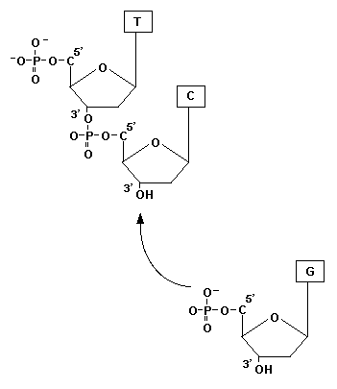
A set of synthetic nucleotides called dideoxynucleotides exists. They are different to deoxynucleotides because they lack the (OH) group to which the next nucleotide will bond. Therefore the elongation of the DNA strand will be terminated.
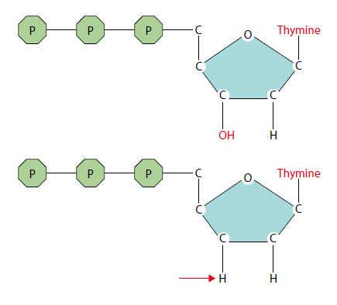
Complete the activities found at http://www.wiley.com/college/pratt/0471393878/student/animations/dna_sequencing/index.html and
http://www.dnalc.org/ddnalc/resources/sangerseq.html
COMPONENTS:
- Target DNA to sequence
- Oligo nucleotide primers
- DNA polymerase
- Deoxynucleotides that are used in extension of strand.
- Dideoxynucleotides marked with a fluorescent marker that will not allow extension of a strand.
- Gel (capillary) electrophoresis
Steps in DNA sequencing
- DNA purification: Genetic material extracted from cell and nucleus by mechanical (grinding) and chemical methods. DNA is precipitated out and removed from the histone proteins.
- Construction of clones: Multiple (thousands of copies) made of the DNA sample (Gene) that will be sequenced using rDNA technology (plasmid as vectors) to clone or PCR technique.
- DNA strand separation: Denaturing of H-bonds by means of heating the sample to 90 degrees.
- Primer annealing: Cooling of sample about 50 degrees and Oligo nucleotide primers of known length will anneal. Primers are artificially made to act as starting point for polymerase to extend new complimentary strands.

- Extension: Increase to favourable temperature for Polymerase to collect nucleotides to attach to primers and extend strands.
- Chain termination: When a dideoxynucleotide gets added to chain by polymerase, no further extension of chanin can happen, because a phosphate group of another nucleotide cannot be attached to the H only bond of a dideoxynucleotide.
- DNA sorting using gel electrophoresis: Capillary gel electrophoresis will be used to sort the strands according to length.
- Florescence detection: As the strands exits the capillary tube (shorter strands will move faster and exit first) a fluorescent light will shine on them and the fluorescent markers of the dideoxynucleotides will show up. Information will be sent to a computer.
- Computer sequence analysis : The computer will translate the different light wavelengths into the corresponding nucleotides and record the position of each.
- A complimentary copy of this DNA sequence will be the sequence of the target DNA
Write down the 10 steps involved in DNA sequencing.

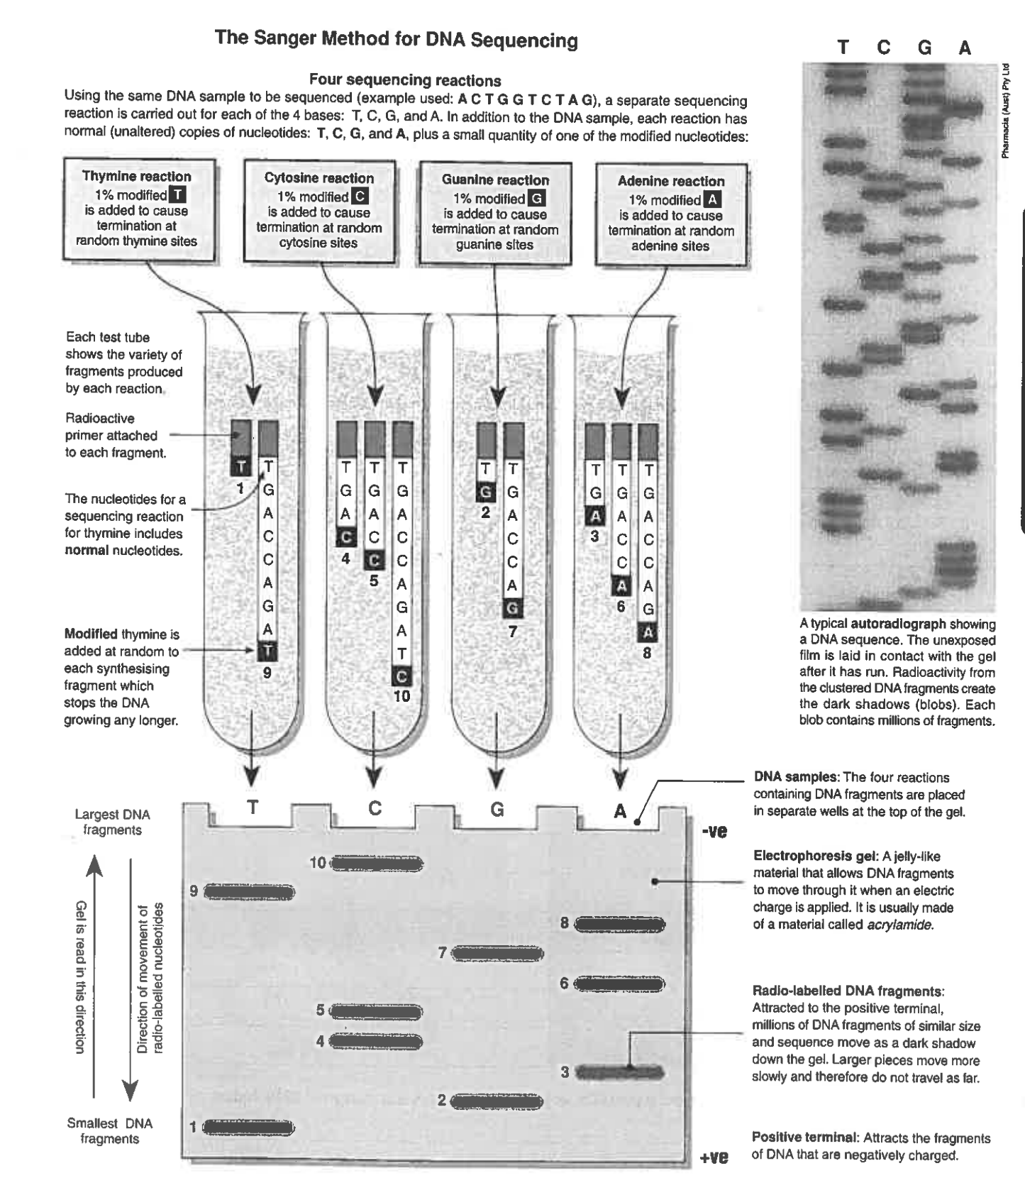

ETHICS OF GMO AND GENETIC ENGINEERING TECHNOLOGY

ETHICS OF GENETIC ENGINEERING

1. In gene technology, is the effect on the organism temporary or permanent?
If permanent can it be inherited by offspring?

2. Is the structure or functioning of the organism affected?

3. Is the health or survival of non-target species affected?
Is there a change in the selective advantage of organism due to its modification?

4. A new gene may disrupt normal gene function. Gene disruption may trigger cancer. Successful expression of the desired gene is frequently very low.

5. The vector used eg bacteriophage can trigger an immune response in patient.

6. The research into biotechnology should not willingly cause harm to an individual or the environment.

7. The course of action should protect the rights of everyone involved.

8. The information gained from the research should advance scientific understanding in the field.

9. Protecting patient privacy is a growing concern, thanks to technology that is making it possible to decode the human genome. But as scientists become adept at deciphering a person’s genetic composition, it is increasingly likely that compromising information about a person’s future health is going to become available.

10. If treatment is unavailable for a disease, genetic knowledge about it may have no use.
11. Genetic knowledge is hereditary, so knowledge of an individual’s own genome has implications for members of their family.
12. Genetic tests are costly, so not accessible to all individuals.
13. Legislation should be in place so that there is no discrimination on the basis of genetic information.

Write down 5 ethical consideration to consider in using Biotechnology

BIOTECHNOLOGY QUESTIONS
